Name :

Purval Madhukar Bhude

Roll No. S20230010193

Subject : Data Structure and Algorithms  
  
Assignment 3

Question 1

recursive relation => T[n] = T[n-1] + 1;

time complexitty : O(n) where n is size of array

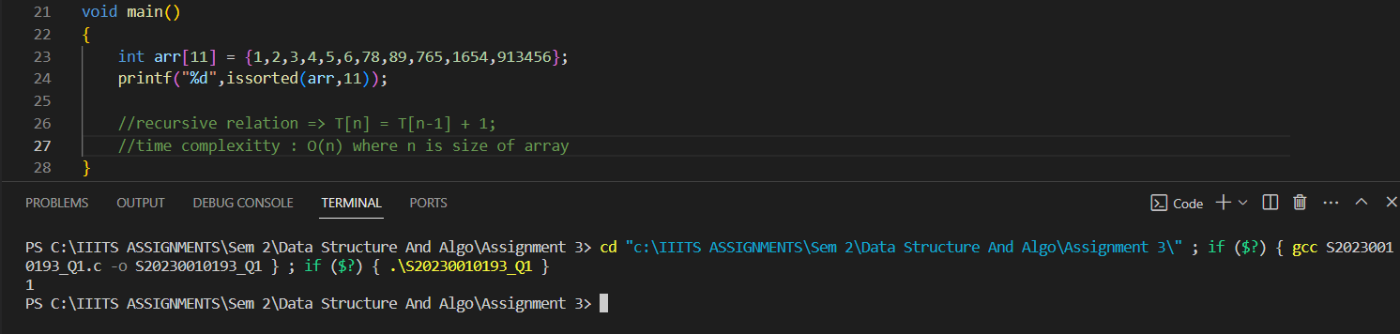

Question 2

time Complexity : O(n\*m) where n and m is row and column respectively

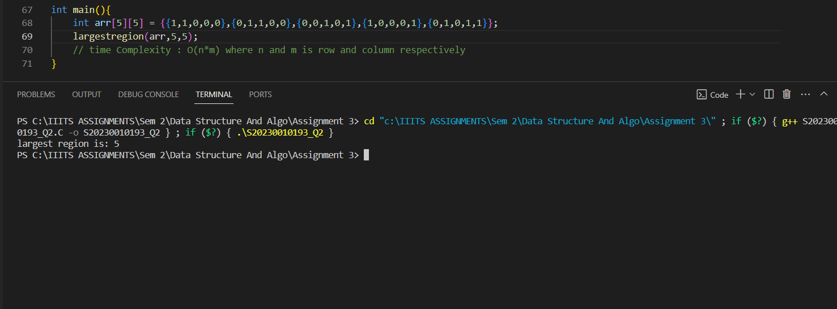

Question 3

time complexity : O(n\*m) where n and m are row and column respectively

space complexity : O(n\*m) where n and m are row and column respectively

